**PROGRAM NO :3**

**AIM:** Implementing basic arithmetic operations of a simple calculator

**PROGRAM CODE:**

|  |  |
| --- | --- |
| Mainac tivity.ja va | package com.example.calculator;  import androidx.appcompat.app.AppCompatActivity;  import android.os.Bundle;  import android.view.View;  import android.widget.Button;  import android.widget.EditText;  public class MainActivity extends AppCompatActivity  {  EditText e1,e2,e3;  Button b1,b2,b3,b4,b5,b6;  @Override  protected void onCreate(Bundle savedInstanceState)  {  super.onCreate(savedInstanceState);  setContentView(R.layout.activity_main);  e1=(EditText)findViewById(R.id.num1);  e2=(EditText)findViewById(R.id.num2);  e3=(EditText)findViewById(R.id.op);  b1=(Button)findViewById(R.id.add);  b2=(Button)findViewById(R.id.subtract);  b3=(Button)findViewById(R.id.divide);  b4=(Button)findViewById(R.id.multiply);  b5=(Button)findViewById(R.id.delete);  }  public void add(View view)  {  int n1=Integer.parseInt(e1.getText().toString());  int n2=Integer.parseInt(e2.getText().toString());  String n3=String.valueOf(n1+n2);  e3.setText(n3);  }  public void del(View view)  {  e1.setText("Enter number 1");  e2.setText("Enter number 2");  e3.setText("Output");  }  public void subtract(View view)  {  int n1=Integer.parseInt(e1.getText().toString());  int n2=Integer.parseInt(e2.getText().toString());  String n3=String.valueOf(n1-n2);  e3.setText(n3);  }  public void divide(View view)  {  int n1=Integer.parseInt(e1.getText().toString());  int n2=Integer.parseInt(e2.getText().toString());  String n3=String.valueOf(n1/n2);  e3.setText(n3);  }  public void multiply(View view)  {  int n1=Integer.parseInt(e1.getText().toString());  int n2=Integer.parseInt(e2.getText().toString());  String n3=String.valueOf(n1*n2);  e3.setText(n3);  }  } |

|  |  |
| --- | --- |
| activity_main.xml | <?xml version="1.0" encoding="utf-8"?>  <androidx.constraintlayout.widget.ConstraintLayout xmlns:android="http://schemas.android.com/apk/res/android"  xmlns:app="http://schemas.android.com/apk/res-auto"  xmlns:tools="http://schemas.android.com/tools"  android:layout_width="match_parent"  android:layout_height="match_parent"  tools:context=".MainActivity">  <TextView  android:layout_width="222dp"  android:layout_height="50dp"  android:layout_marginStart="92dp"  android:text="Email ID"  android:textSize="36sp"  app:layout_constraintBottom_toBottomOf="parent"  app:layout_constraintLeft_toLeftOf="parent"  app:layout_constraintRight_toRightOf="parent"  app:layout_constraintStart_toStartOf="parent"  app:layout_constraintTop_toTopOf="parent"  app:layout_constraintVertical_bias="0.327" />  <EditText  android:id="@+id/editText"  android:layout_width="256dp"  android:layout_height="55dp"  android:ems="10"  android:inputType="textEmailAddress"  app:layout_constraintBottom_toBottomOf="parent"  app:layout_constraintEnd_toEndOf="parent"  app:layout_constraintHorizontal_bias="0.593"  app:layout_constraintStart_toStartOf="parent"  app:layout_constraintTop_toTopOf="parent"  app:layout_constraintVertical_bias="0.44" />  </androidx.constraintlayout.widget.ConstraintLayout> |

**OUTPUT:**

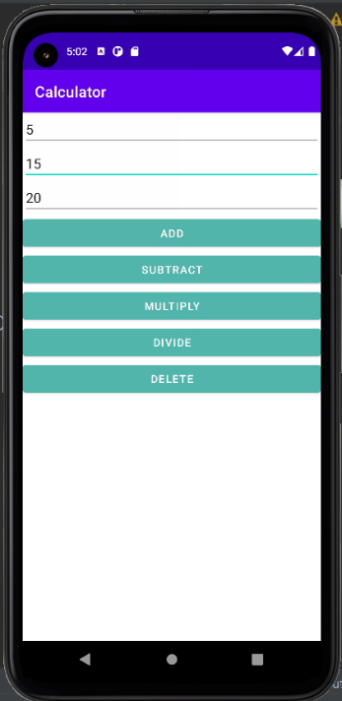

RESULT

Program Has Been Succesfully Executed And Output Is Obtained.